Team 2 Submission 1

Benjamin Frost, Nasra Rage, Nimet Ozakca, Zhiheng Jiang

February 20, 2020

Contents

1 Requirements Specification 2

1.1 Description of the Existing System 2

1.2 Use Case Diagram 2

1.3 Use Case Specifications 2

1.4 Indexed List of Use Cases 2

2 System Design 2

2.1 Design Class Diagrams 2

2.2 ER Diagram 2

2.3 GUI Designs 2

# Requirements Specification

## Description of the Existing System

The software they have used for 20 years has reached the point where its further maintenance is problematic and they want a new software product to reflect the recent advances in user interfaces and more flexibility, which will eliminate the difficulties and limitations of the old software. AirVia Ltd want to evaluate the new software before they decide whether to make it mandatory for all travel agents selling their tickets.

The current system AirVia uses is an old system, it has been used for more than 20 years, the data in the system is reaching the edge of overflow and the Y2K problem may occur any time as the time system was fixed by "windowing" method rather than the rewrite. There is no graphical user interface for the current system, which makes the new employee, especially for the younger generation, feel hard to involve. For the current system, there is only one type of user that can have access of the entire system, which makes the data insecure and difficult to manage. If the customer or travel agent is paid by foreign currency the exchange rate has to be manually checked and updated by the office manager, AirVia often loses money by that. The commission rate for each travel agent might be different subject to different cases, it is very hard to change the hardcoded commission rate due to the version compatibility problem. Lastly, there are very limited ways to categories the customers which leads the difficulty in the business analysis.

## Use Case Diagram

Version 2.3.9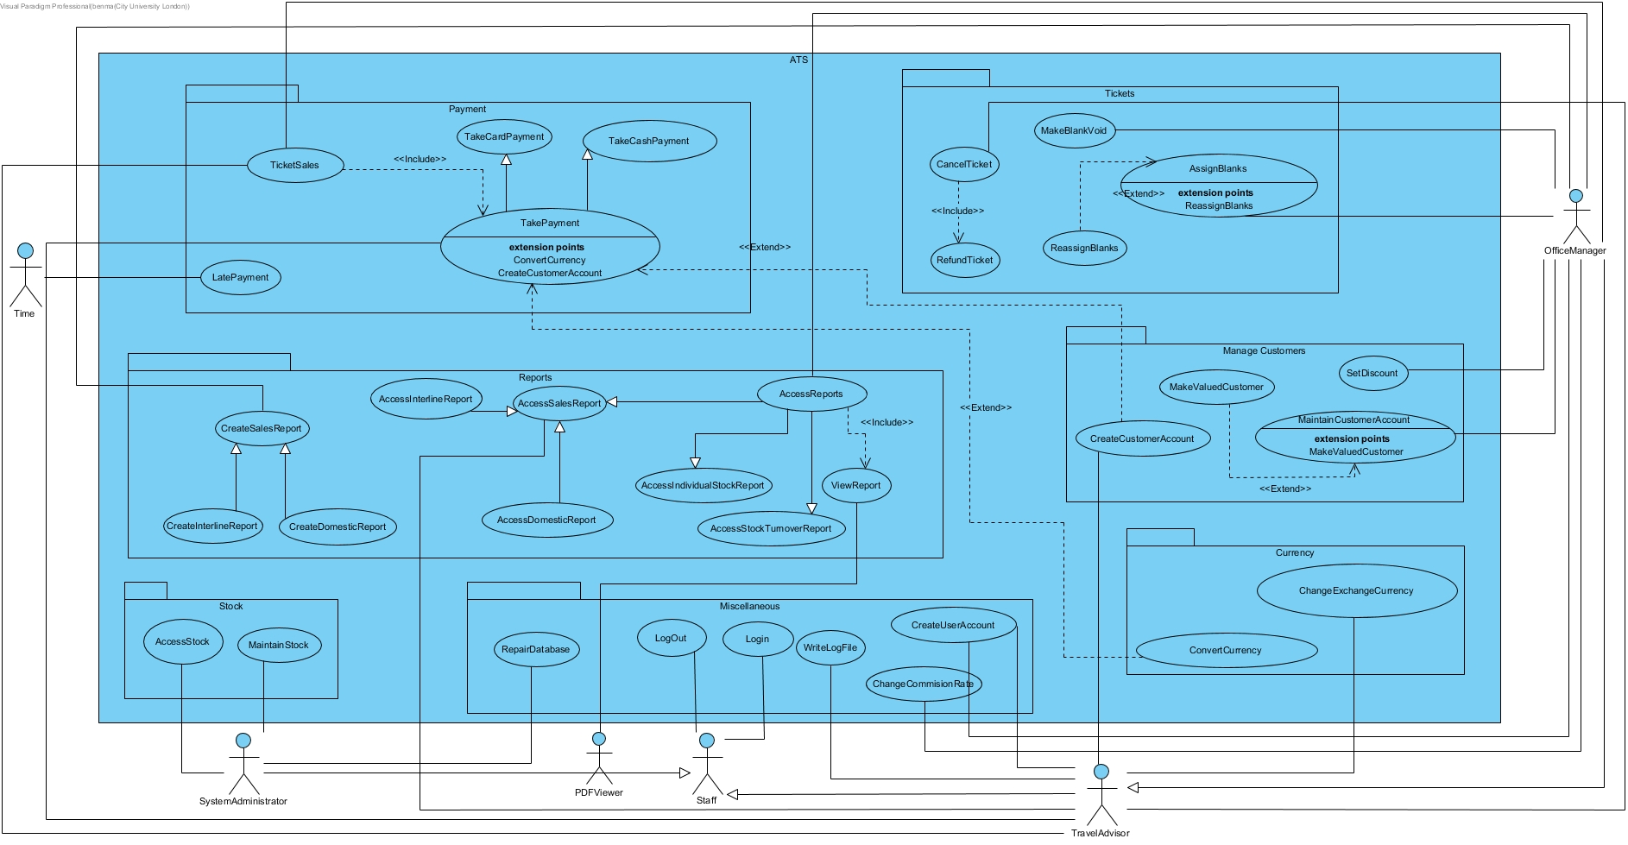

## Use Case Specifications

## Indexed List of Use Cases

# System Design

## Design Class Diagrams

## ER Diagram

## GUI Designs